Filtering the spatial properties of an image in Fourier Space

To test spatial frequency dependency of computational lightness models, specifically if band-pass white noise introduced into spatial frequency band corresponding to edges disrupts lightness computation, we need a robust method of producing noise masks which we can then apply to such models and observe any interference with the processing.

We can view the spatial frequency spectrum by applying a 2D Fourier Transform to an image and we get one of the “Fourier unmasked” plots below. The distance from the central peak (white = high intensity), is equal to the spatial frequency of a particular component of the image, whilst the angle from the vertical is the orientation of that component. We can apply masks to this spectrum to extract specific component of the initial image. Look at the second row and we can see the “Fourier masked” spectrum. On the left we have a ring which allows that particular band of frequencies to pass, whilst on the right only the very central frequencies pass. The radius of the inner and outer is the spatial frequency range of this type of band pass filter.
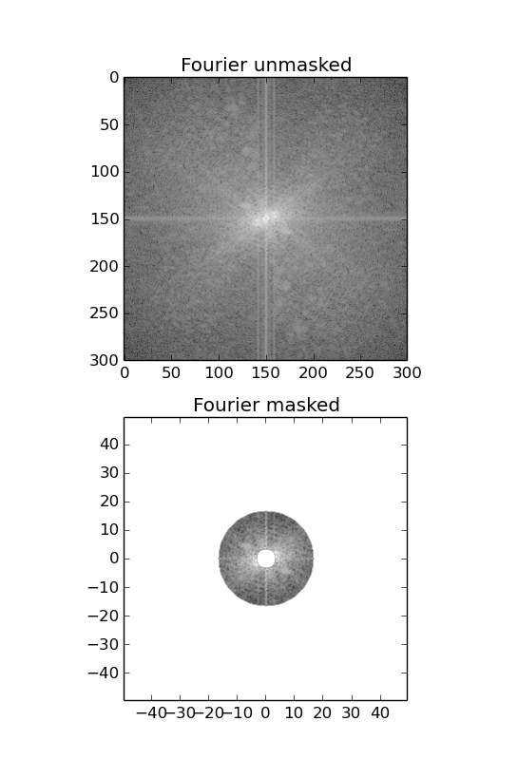
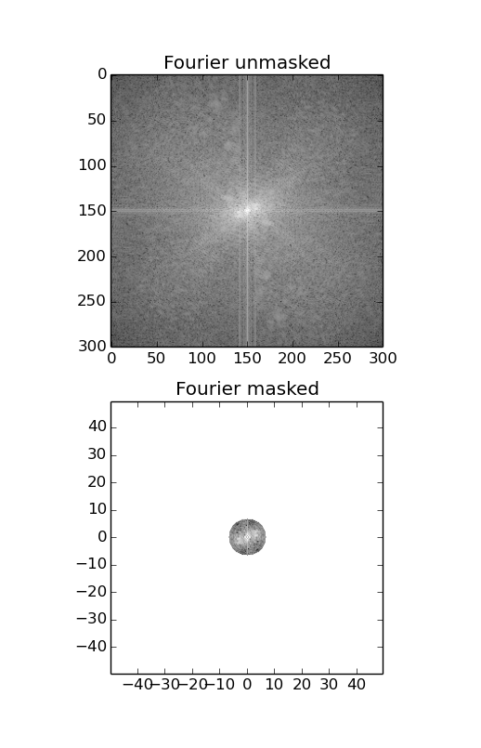
We can then observe how these types of filter affect the resulting output image, by doing the inverse 2D Fourier Transform on these “Fourier masked” images. They can be seen below with their original inputs.
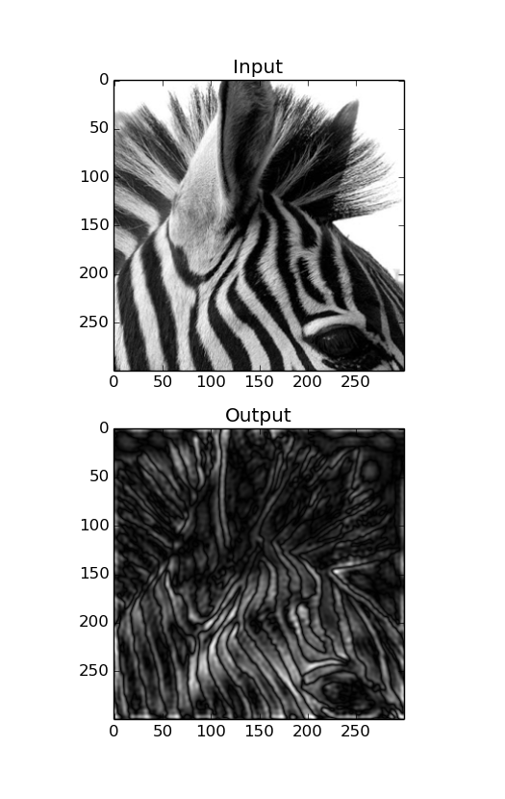
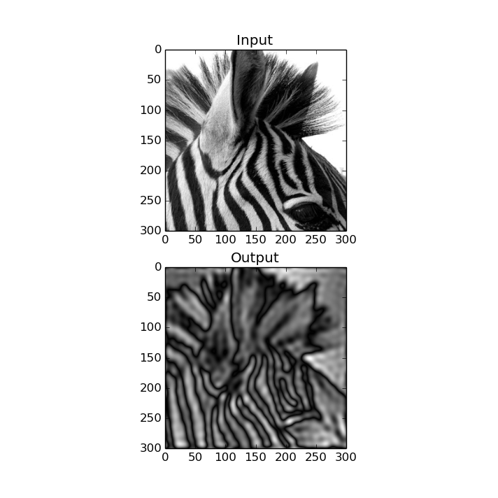

So now if we input white noise across all spatial frequencys, we have a robust method to apply a band-pass filter which will create an isolated band of noise frequencies.

